**Individual assignment II: Market failure – Water management**

**Task 1 – Externalities**

Draw the typical market demand and supply curves/functions of a perfectly competitive market. Do not forget to label the curves and the axes. You do not need to plug in numbers.

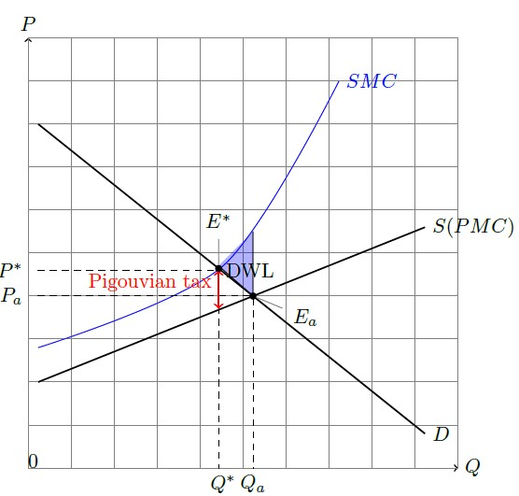

1. Suppose that the production is polluting and causes a negative externality. Describe below the components of the social marginal costs of production?

The costs of producing one more unit of a good or service considering both private

production costs and externalities.

1. Draw a social marginal costs (SMC) curve assuming that marginal external costs are increasing with production in your ﬁgure above.
2. Explain in words what a negative externality is and give and discuss three environmental examples.

Definition of the book: effects of a market transaction that change the utility, negatively, of those outside the transaction. Examples:

* Production which causes pollution generates clean-up costs.
* Dam building prevents fish from swimming upstream, therefore generating negative impacts for upstream fishermen.
* Excessive development creates less aesthetically appealing landscapes

1. Indicate in your ﬁgure (1) the optimal (Q∗) and actual (Qa) equilibrium quantities sold, (2) the optimal (E∗) and actual (Ea) market equilibria, and (3) the optimal (P∗) and actual (Pa) prices.
2. Indicate the deadweight loss in the ﬁgure.
3. Indicate the optimal level of a Pigovian tax in the ﬁgure.

**Task 2 – Negative externalities**

Consider the following supply-and-demand schedule for steel:

|  |  |  |  |  |  |  |  |  |  |
| --- | --- | --- | --- | --- | --- | --- | --- | --- | --- |
| Price per ton (€) | 20 | 40 | 60 | 80 | 100 | 120 | 140 | 160 | 180 |
| Qd (million tons) | 200 | 180 | 160 | 140 | 120 | 100 | 80 | 60 | 40 |
| Qs (million tons) | 20 | 60 | 100 | 140 | 180 | 220 | 20 | 300 | 340 |

Pollution from steel production is estimated to create an external cost of €60 per ton.

1. Using a supply-and-demand graph to support your answer, what is the unregulated market equilibrium (price and quantity) in the steel market?

The market for steel is expressed in the graph below. At the equilibrium price the quantity on the supply curve equals the quantity on the demand curve. We see from the table that this occurs at a price of $80 per ton with 140 million tons of steel. This market equilibrium is shown in the graph below.

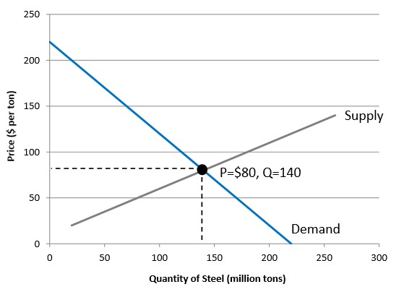

1. Add the external costs to your graph from part (a). What is the socially optimal outcome in the steel market (price and quantity)? What economic policy could be implemented to achieve the social optimum?

To incorporate the external cost of $60 per ton, we add $60 to each point on the market supply curve, as shown in the graph below. The market supply curve depicts the private marginal costs while the social supply curve also considers the social marginal costs. So, for example, while 140 million tons are supplied on the private supply curve at a price of $80 per ton, 140 million tons would be supplied on the social supply curve at a price of $140 per ton. Considering the social costs, the socially efficient outcome would result in a price of steel of $120 per ton and a quantity of 100 million tons. Note that this result reduces the equilibrium quantity and raises the equilibrium price.

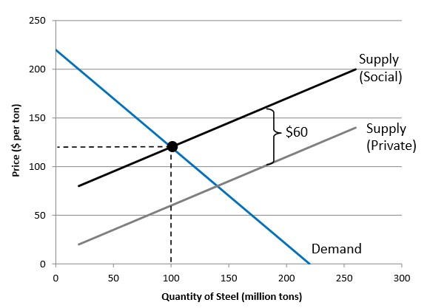

To achieve the socially efficient outcome, we need to internalize the externality. One way to do this is to institute a pollution tax per unit of steel produced. If this tax were set at $60 per ton, the market supply curve would shift up to the social supply curve, and the efficient outcome would result. Another option is to limit the amount of steel that can be produced using a transferable permit system. The total number of permits would limit steel production to 100 million tons and the permits would be allocated to firms, perhaps using an auction. Firms could then buy and sell permits among themselves.

1. Using either your previous graph or creating a new one, use welfare analysis to demonstrate that social welfare is greater at the social optimum than with the unregulated market outcome.

We first consider social welfare in an unregulated market. The graph below presents consumer surplus (area A) and producer surplus (area B) at the unregulated equilibrium from part (a).

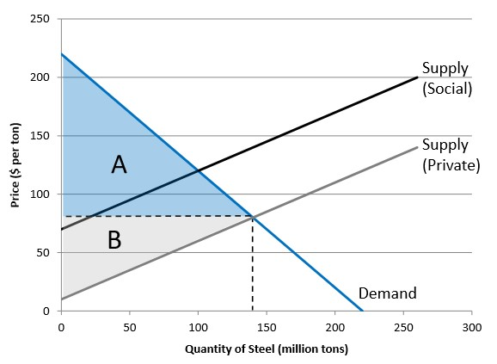

But we also need to deduct the externality damages to obtain the final social welfare for the unregulated market outcome. The externality damages are represented by the area between the private and social supply curves, up to the market quantity of 140 million tons. This is shown as the dark gray-shaded area in the graph below. Thus net social welfare is the sum of areas A’ and B’ (note that B’ is just the small portion of producer surplus that is not cancelled out by the externality damages) minus area C (which is just the area of the externality damages that does not overlay either consumer or producer surplus, shown as a dotted triangle)

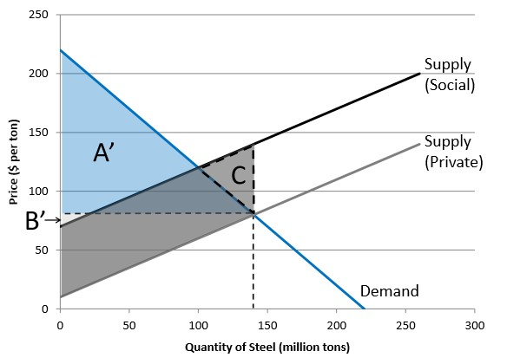

We need to compare this to social welfare at the social optimum, as would be achieved with a Pigovian tax set at the correct price of $60 per ton. This is shown in the graph below. Consumer surplus is area A” and producer surplus is area B”. Area D represents both the remaining externality damage and the tax revenues. Thus externality damages and tax revenues cancel out, leaving net social welfare as the sum of areas A” and B”. Note that (A”+B”) equals (A’+B’) from the unregulated outcome. But at the social optimum we don’t subtract area C from the graph above. Thus the net gain at the social optimum is area C.

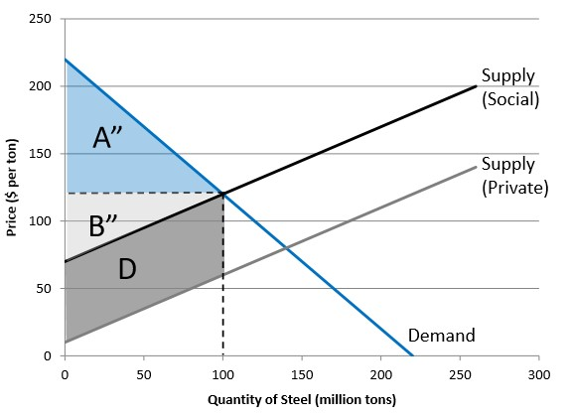

**Task 3 – Negative Externalities**

Suppose the demand curve for an electronic tablet is:

Pd = 200 - 3Q

Where Q is the number demanded in thousands. The supply curve is:

Ps = 20 + 3Q

Where, again Q is measured in thousands. Production of tablets, considering the materials used, the wastes created, transportation, and packing results in €30 of external costs per tablet.

1. Solve the equilibrium price and quantity in the tablet market without any regulation, both algebraically and using a supply-and-demand graph.

To solve for equilibrium we set Pd equal to Ps and solve for quantity:

200 – 3Q = 20 + 3Q 180 = 6Q Q=30 (30,000 tablets)

Next, substitute this quantity into either the supply or demand equation. The equilibrium price based on either equation should be the same.

Pd = 200 – 3(30) Ps = 20 + 3(30) Pd = 200 – 90 Ps = 20 + 90 Pd = $110 Ps = $110

This equilibrium is illustrated in the graph below.

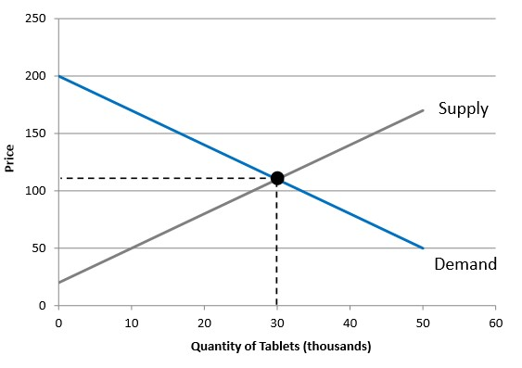

1. What is the social welfare in the tablet market without any regulation? Solve for consumer surplus, producer surplus, and externality damage algebraically. (Be careful about the units.) Also show these areas in your graph from part (a).

The total social welfare is the sum of consumer and producer surplus minus the externality damage. Consumer surplus is represented in the graph below as the blue-shaded triangle, with a height of $90 and a base of 30,000 tablets. Note that we solve for the price on the demand curve at a quantity of zero as $200. The height of the consumer surplus triangle is (200-110)=90. Thus consumer surplus is:

CS = 90 * 30,000 * 0.5 CS = $1,350,000

Producer surplus is represented by the gray-shaded region in the graph below, between a price of $20 and $110 and with a base of 30,000 tablets. Note that we obtained a price of $20 along the supply curve by solving for price at a quantity of zero. Thus producer surplus is:

PS = 90 * 30,000 * 0.5 PS = $1,350,000

Finally, the externality damage is $30 per tablet for 30,000 tablets, or $900,000. So total social welfare is:

Welfare = $1,350,000 + $1,350,000 - $900,000 Welfare = $1,800,000

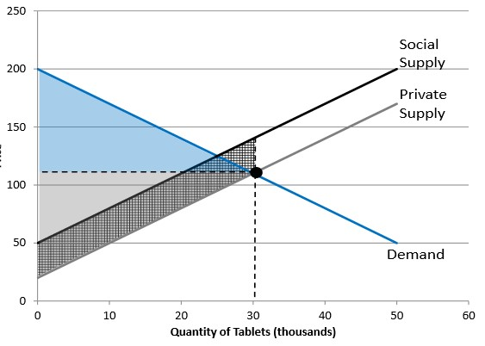

1. If the correct Pigovian tax is instituted, what will be the new equilibrium price and quantity in the tablet market? Solve algebraically and also show this on a graph. (The same graph as above or a new one.)

The correct Pigovian tax fully internalizes the negative externality damage of $30 per tablet. This damage is added to the supply curve, shifting it upward by $30. Algebraically, we add 30 to the intercept of the initial supply curve to obtain the supply curve with the tax (also the social supply curve) of:

Ptax = 50 + 3Q

To obtain the efficient equilibrium outcome, we set the supply curve with the tax equal to the original demand curve to solve for quantity:

200 – 3Q = 50 + 3Q 150 = 6Q Q=25 (25,000 tablets)

Then substitute this equilibrium quantity into either the supply curve with the tax or the demand curve to obtain the new equilibrium price:

Pd = 200 – 3(25) Ptax = 60 + 3(25) Pd = 200 – 75 Ptax = 60 + 75 Pd = $125 Ptax = $125

This new equilibrium is illustrated in the graph below.

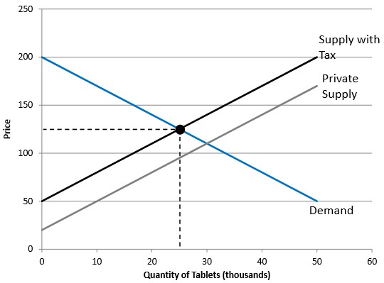

1. What is total social welfare in the tablet market with the correct Pigovian tax? Solve for consumer surplus, producer surplus, the externality damage, and the tax revenues algebraically. Also show these areas in your graph from part (c).

Consumer surplus is shown in the graph below as the blue triangle, area A. The height is the difference between the intercept ($200) and the new equilibrium price ($125), or $75. The base is 25,000 tablets. So consumer surplus is:

CStax = 75 * 25,000 * 0.5 = $937,500

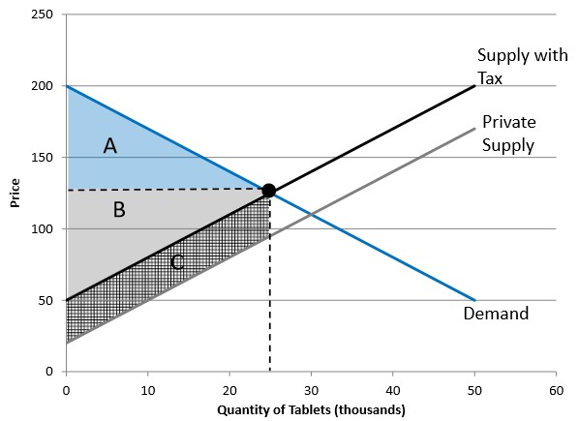

Producer surplus is show above as the gray triangle, Area B. The height is the difference between the intercept ($50) and the equilibrium price of $125, or $75. The base is 25,000 tablets. So producer surplus is:

PStax = 75 * 25,000 *0.5 = $937,500

The externality damages and the tax revenues are both equal to Area C in the graph above (the cross-hatched area), and thus cancel out in the welfare analysis. These are both equal to $30 per tablet multiplied by the quantity of 25,000 tablets:

Tax Revenue/Externality Damage = $30 * 25,000 = $750,000

Net social welfare is thus equal to the sum of consumer and producer surplus, minus the externality damage, plus the tax revenue:

Welfaretax = $937,500 + $937,500 - $750,000 + $750,000 Welfaretax = $1,875,000

Net social welfare before the tax (the unregulated outcome) was $1,800,000. With the Pigovian tax social welfare has increased by:

Welfare Gain = $1,875,000 - $1,800,000 = $75,000

Thus this analysis demonstrates that instituting a correct Pigovian tax clearly increases social welfare relative to the unregulated outcome.

**Task 4 – Coase Theorem**

A chemical factory is located next to a farm. Emissions from the factory damage crops on the farm. The marginal beneﬁts of emissions to the factory and the marginal costs of damage to the crops are as follows:

|  |  |  |  |  |  |  |  |  |  |
| --- | --- | --- | --- | --- | --- | --- | --- | --- | --- |
| Quantity of emissions | 50 | 100 | 150 | 200 | 250 | 300 | 350 | 400 | 450 |
| Marginal benefit to factory (x €1000) | 160 | 140 | 120 | 100 | 80 | 60 | 40 | 20 | 0 |
| Marginal cost to farmer (x €1000) | 55 | 65 | 75 | 85 | 95 | 105 | 115 | 125 | 135 |

1. Suppose that there are no laws preventing the factory from emitting pollution. How much pollution will it emit? Brieﬂy explain why.

As pollution is an external cost, the firm will continue to increase emissions as long

as it receives a positive marginal benefit. In this case, the firm has the property right to pollute.

Disregarding external costs, the firm would produce 450 units of emissions, until marginal benefits equal zero. Although the farmer is damaged by each unit of pollution, the firm does not take this into account.

1. From an economic point of view, what is the socially optimal level of emissions from the chemical factory? Brieﬂy explain why, using a graph to support your answer.

The socially optimal level of emissions is reached at the point where the marginal

benefit to the factory just equals the marginal cost to the farmer. The first few units of

emissions make sense for a social perspective because the factory's benefits significantly exceed the

costs to the farmer. Marginal benefits exceed marginal costs up to point A in the graph, at a

quantity of 225 units of emissions. At this point the marginal benefits and marginal costs are both

$90,000.



1. Again, assuming there are no laws preventing the factory from polluting, describe how the socially eﬃcient outcome could be achieved using the Coase Theorem.

The farmer would be willing to pay the factory to reduce their emissions as long as the

marginal payment is less than the marginal damage to the farmer. The factory would be willing to accept payment to reduce its emissions as long as the payment is greater than the marginal benefit associated with its emissions. They will trade up to point A, where MAC = MAB.

1. List the assumptions/conditions of the Coase Theorem.

Property rights well defined, can be traded, no (or low) transaction costs.

1. Sometimes these assumptions do not hold in practice. Choose one of these conditions and discuss why it would not hold for the chemical factory example above.

*Possible answers include*: A specialized company might be needed to measure the amount

of emissions, which would raise transaction costs. The factory and the farmer might be based in a country with underdeveloped institutions, such that property rights are hardly defined.

*Water Management*

**Task 5 – Water pricing**

Suppose that in a particular area the consumption of water varies tremendously throughout the year, with average household summer use exceeding winter use by a great deal. What effect would this have on an efficient rate structure for water?

Since the amount of capacity needed would depend on the maximum flow during the year, the extra cost of expanding capacity during this high-flow period should be reflected in higher prices charged to users during these periods.

**Task 6 – Water pricing**

Is a flat-rate or flat-fee system more efficient for pricing scarce water? Why?

Assuming the rate was correct, the flat rate would be more efficient because it would confront the user with a positive marginal cost of further consumption. The marginal cost of further consumption with a flat fee is zero.

**Task 7 – Water pricing**

Water is an essential resource. For that reason moral considerations exert considerable pressure to assure that everyone has access to at least enough water to survive. Yet it appears that equity and efficiency considerations may conflict. Providing water at zero cost is unlikely to support efficient use (marginal cost is too low), while charging everyone the market price (especially as scarcity sets in) may result in some poor households not being able to afford the water they need. Discuss how block-rate pricing attempts to provide some resolution to this dilemma. How would it work?

The key to using the tiered system for this purpose is to distinguish water needs by monthly volume. Specifically, the first block could contain a basic amount of water that fulfills essential purposes, while the second block contains all other water above that amount. The first block would be priced at a low level, while the second block price would reflect all of the scarcity rent generated by the marginal user cost as well as the marginal cost of extraction and distribution. Since the positive marginal user cost means that the marginal revenue for that block would be above the marginal extraction plus distribution cost, the utility could still cover its expenses despite the low cost of the first units. Meanwhile, because most households would consume at least some more water than allowed in the first block, the price they would face for the additional water would be the efficient (marginal cost) price in the second block. The fact that the price for the additional water would be the efficient price would preserve incentives to conserve an efficient amount.